EXPERIMENT 1 B

IMPLEMENTATION OF CRISP-DM USING DIABETES DATASET

Aim
To implement the CRISP-DM methodology by analyzing a diabetes patient dataset using Python and Pandas.

Algorithm

Step 1: Business Understanding
Define the objective of analyzing diabetes patient data and identifying diabetes classification patterns.

Step 2: Data Understanding
Import the dataset and examine its structure, data types, and summary statistics.

Step 3: Data Preparation
Check missing values, duplicate records, and convert required columns into suitable data types.

Step 4: Modeling
Analyze important diabetes parameters such as Age, BMI, HbA1c, and diabetes classification.

Step 5: Evaluation
Evaluate the analysis using statistical summaries and diabetes class distribution.

Step 6: Deployment
Present the analyzed results and insights for reporting and decision-making.

Program 1: Business Understanding
Objective:
Analyze diabetes patient data to understand health parameters and diabetes classification.

Program 2: Data Understanding
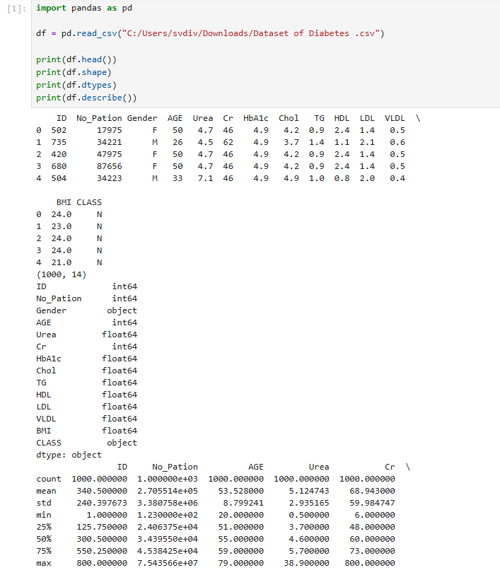

Program 3: Data Preparation
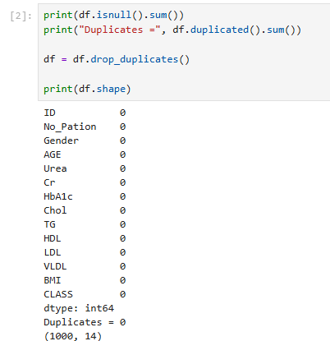

Program 4: Modeling

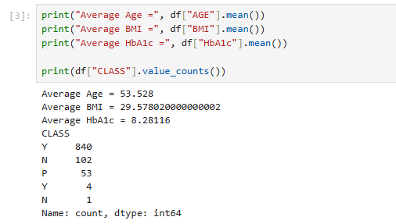

Program 5: Evaluation
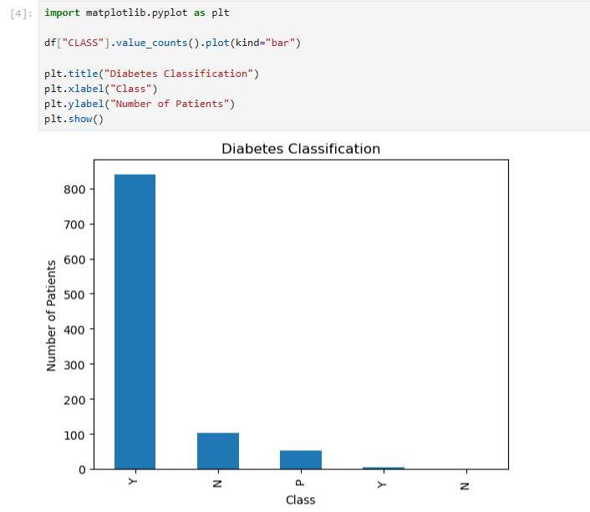

Program 6: Deployment

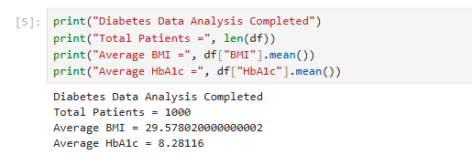

Result
Thus, the CRISP-DM methodology was successfully implemented on the diabetes dataset. The data was imported, understood, prepared, analyzed, evaluated, and the results were presented successfully using Python and Pandas.

IMPLEMENTATION OF SEMMA USING DIABETES DATASET

Aim
To implement the SEMMA methodology by analyzing diabetes patient data using Python and Pandas.

Algorithm

Step 1: Sample
Load the diabetes dataset and select the required patient records.

Step 2: Explore
Examine the dataset structure, statistics, and diabetes classification.

Step 3: Modify
Handle missing values, remove duplicates, and prepare the data.

Step 4: Model
Analyze the relationship between health parameters and diabetes classification.

Step 5: Assess
Evaluate the results using statistics and visualizations.

Program 1: Sample

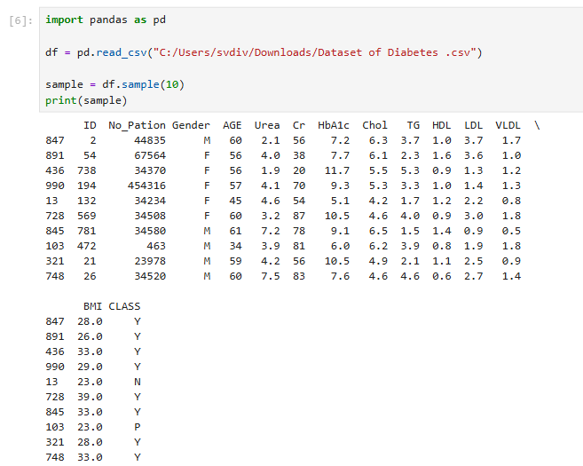

Program 2: Explore

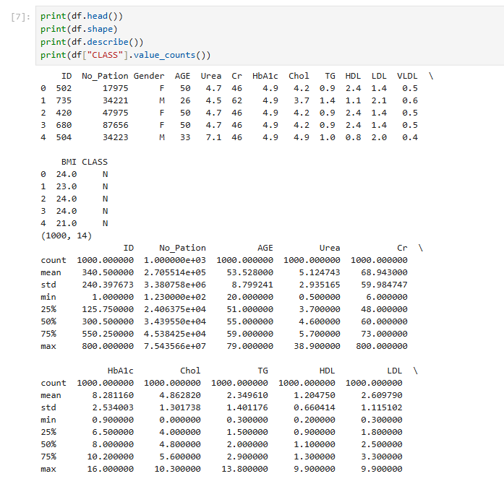

Program 3: Modify
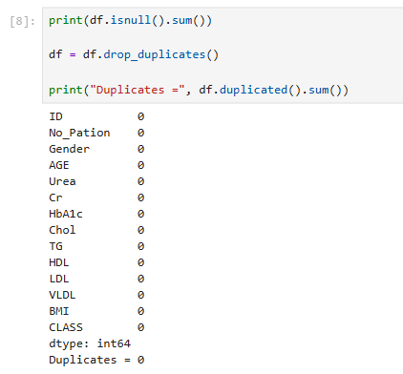

Program 4: Model

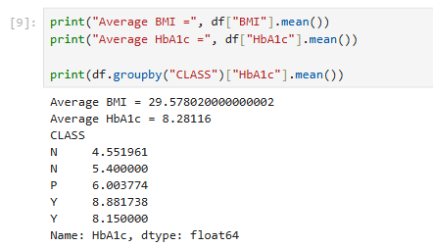

Program 5: Assess

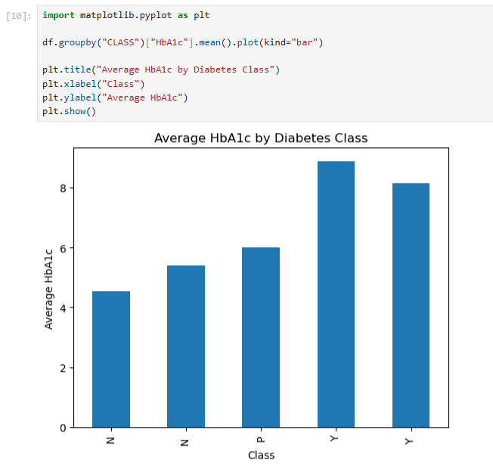

Result
Thus, the SEMMA methodology was successfully implemented on the diabetes dataset. The data was sampled, explored, modified, modeled, and assessed using Python and Pandas.

IMPLEMENTATION OF KDD USING DIABETES DATASET

Aim
To implement the KDD (Knowledge Discovery in Databases) methodology by analyzing diabetes patient data using Python and Pandas.

Algorithm

Step 1: Data Selection
Select the diabetes dataset and required health attributes.

Step 2: Data Preprocessing
Check missing values and duplicate records.

Step 3: Data Transformation
Convert categorical data into numerical form where required.

Step 4: Data Mining
Analyze diabetes classification and important health parameters.

Step 5: Pattern Evaluation
Identify useful patterns using statistics and visualization.

Step 6: Knowledge Presentation
Present the discovered patterns using charts and results.

Program 1: Data Selection

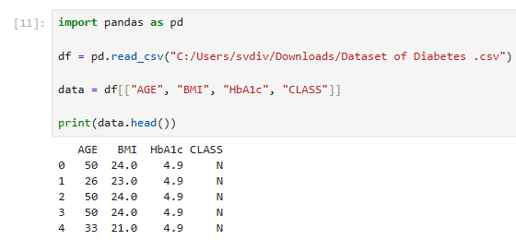

Program 2: Data Preprocessing

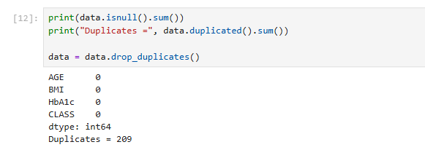

Program 3: Data Transformation

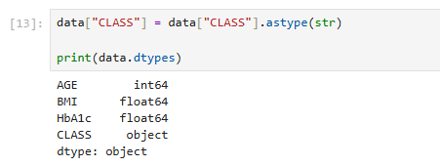

Program 4: Data Mining

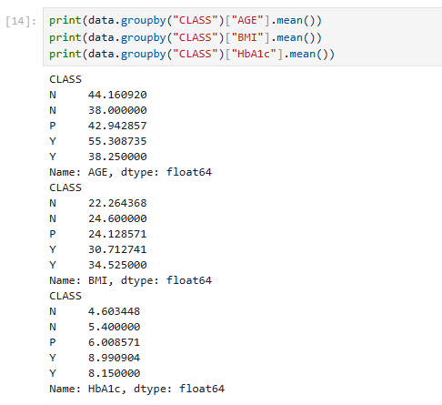

Program 5: Pattern Evaluation

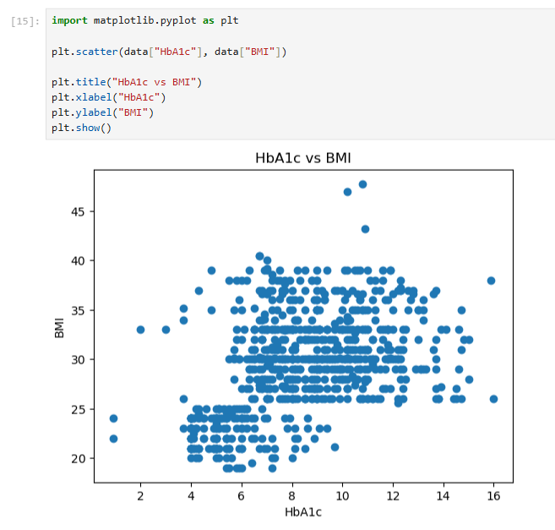

Program 6: Knowledge Presentation

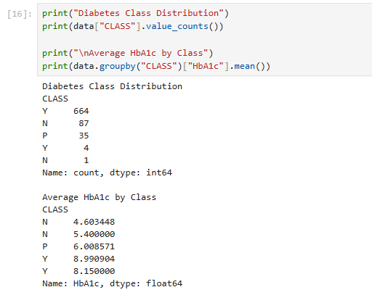

Result
Thus, the KDD methodology was successfully implemented on the diabetes dataset. The data was selected, preprocessed, transformed, analyzed, evaluated, and useful knowledge was obtained using Python and Pandas.

